UNIT3 - Extra Practice

1. Classify the adjectives.

**MODERN – CONFORTABLE – BIG – SMALL – SHORT – INTERESTING – NICE – DIFFICULT - WEAK**

|  |  |
| --- | --- |
| -er | more / less |
| weaker |  |

**2. What’s your opinion? Choose and write.**

**1.** Maths / English / interesting

……………………………………………………………….………………….

**2.**tigers / lions /dangerous

……………………………………………………………….………………….

**3.** German / Russian/ difficult

……………………………………………………………….………………….

**4.** planes / trains / comfortable

……………………………………………………………….………………….

**5.** hamsters / rabbits / active

……………………………………………………………….………………….

**6.** tablets/ phones / cheap

……………………………………………………………….………………….

**3. Compare the forms of transportation using the words in the box.**

most leastfastdangerousexcitingexpensiveslow

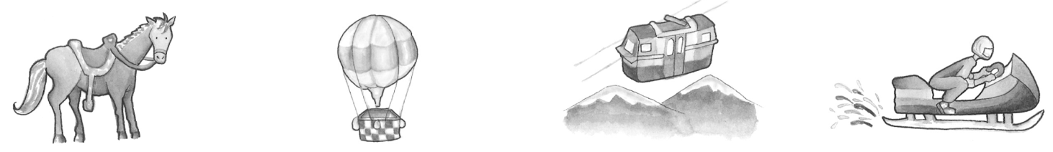

horsehot-air balloon cable car snowmobile

**1.** The horse is the ………………………………… form of transportation.

**2.**………………………………………………………….…………………….

**3.** ………………………………………………………………………………..

**4.** ……………………..…………………………………………………………