**UNIT 1 – Test**

**Name: …………**

**1. Look and correct the sentences.**

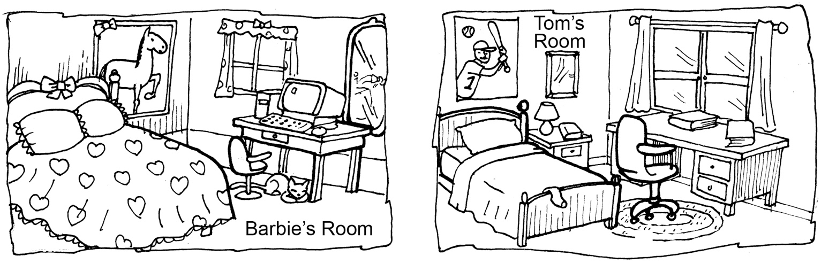

**1.**Thereis a small window.

*There isn’t a small window.*

*Thereis a big window.*

**2.** There is a big mirror next to the poster.

………………………………………………………………………………....

………………………………………………………………………………....

**3.** There are four books under the desk.

………………………………………………………………………………....

………………………………………………………………………………....

**4.** There is a phone next to the lamp.

………………………………………………………………………………....

………………………………………………………………………………....

**5.** There are two pillows on the bed.

………………………………………………………………………………....

………………………………………………………………………………....

**6.** There is one T-shirt on the bed.

………………………………………………………………………………....

………………………………………………………………………………....

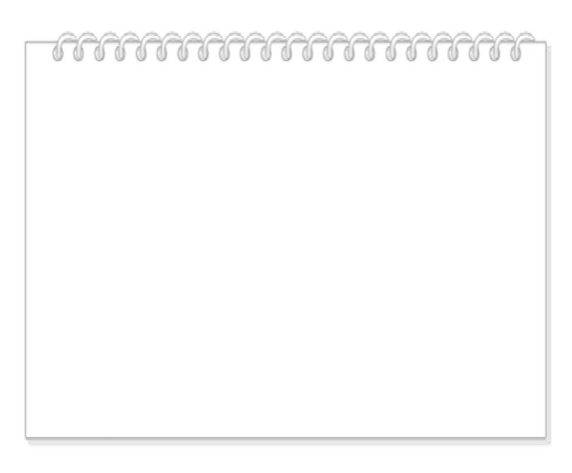**2. Read the information and answer. (2 points)**

**My city**

Theatre NO

Zoo NO

Toy shop YES

Restaurants YES

Hotels NO

1. Is there is a toy shop?  
   …………………………………………………….….……
2. Are there any hotels?  
   …………………………………………………….….……
3. Is there a zoo?  
   …………………………………………………….….……
4. Are there any restaurants?  
   …………………………………………………….….……

**3. Listen and write *T* (*True*) or *F* (*False*). 2**

**What’s your personality type?**

**1.** He doesn’t like reading. ………

**2.** She’s a dreamer. ………

**3.**She likes when other people tell her what to do. ………

**4.** He hates following fashion. ………

**4. Answer about you.**

**1.** What do you love doing? ………………………………………………………….………………..………..

**2.**Do you like playing any musical instruments? …………………………….…….…………………………..

**3.** What do you hate doing? ……………………………………………………………………………………..

**4.**Do you like eating vegetables? ………………………………………………………..……………………..

**5. Write about a friend.**

My friend ………………………………….…….. (name). ……………………………………………… (nationality). …………………………………………………..… (age). ………………………………………………………… (hair and eyes).I think that my friend ……………………………….………………………….……………… (personality type) because ………………………………………………………… .

………………… has got ……………………………………………...……………………………………….. (family). …………………………………………………………………………….. (pet).