**UNIT 2 TEST**

**1. Read and complete with *must*, *mustn’t* or *Can.***

**1.**………………………….I close the window? I’m cold.

**2.** You ………………………….be late to school.

**3.** ………………………….I use your pen, please?

**4.** You ………………………….finish your project for tomorrow.

**5.** You………………………….be kind to your classmates.

**6.** You ………………………….speak loudly in the library.

**2. Label the cooking actions.**

1. **2.**  **3.**

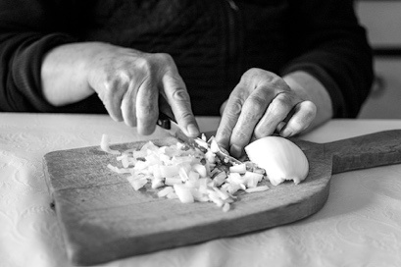 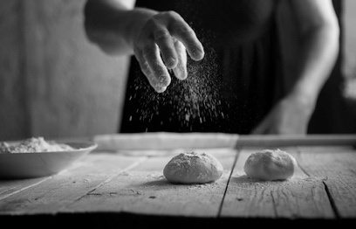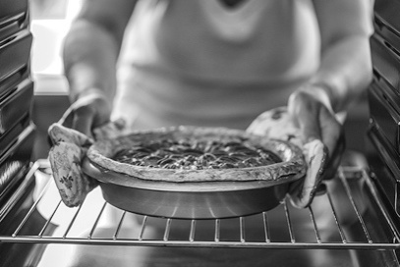

……………………… the onion …………………..…..…… flour ……..………………… the cake

**3. Read John’s diary and answer.**

Monday  
English lesson

Tuesday  
swimming

Wednesday  
dentist at 4 pm

Thursday  
Sam’s party

Friday  
swimming

Saturday  
shopping

Sunday  
picnic with friends

**1.** What is John going to do on Monday? ……………………………………………………………

**2.**When is he going to have swimming practice? ……………………………………………………………

**3.** Who is he going to have a picnic with? ……………………………………………………………

**4.**What time is he going to the dentist? ……………………………………………………………

**4. Write about your plans. (5 points)**

…………………..……………………………………………………………………………… next month.

…………………..……………………………………………………………………………… in winter. …………………..……………………………………………………………………………… after lunch.

…………………..……………………………………………………………………………… on Saturday.

…………………..……………………………………………………………………………… tomorrow afternoon.