**UNIT 3**

**1. Complete with the comparative forms of the adjectives.**

**1.** A giraffe is …………………. (tall) than a kangaroo.

**2.** A monkey is …………………. (funny) than a lion.

**3.** A giraffe’s neck is …………………. (long) than a hippo’s neck.

**4.** A hippo’s tail is …………………. (short) than a tiger’s tail.

**5.** A lion is…………………. (dangerous) than a monkey.

**2. Look and write superlative sentences.**

**TALL – CAREFUL - YOUNG – BAD - HEAVY**

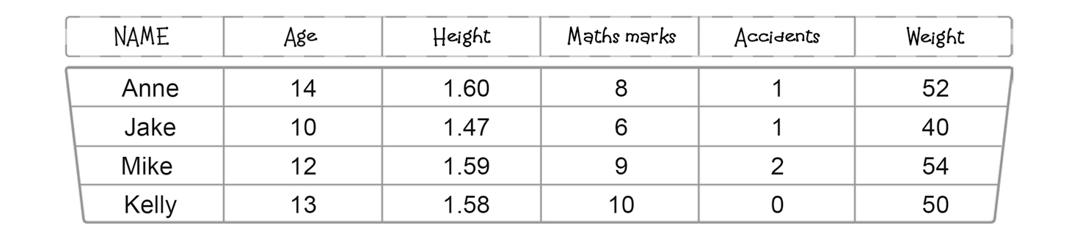

**1.(Anne-height)** *Anne is the tallest.*

**2. (Jake-age)** …………………………………………………………………….…….

**3. (Mike-weight)** …………………………………………………………………….…….

**4. (Jake-Maths)** …………………………………………………………………….…….

**5. (Kelly-accidents)** …………………………………………………………………….…….

**3. Complete the questions with the correct form of the adjectives.**

**What’s your opinion?**

**1.** Who is ……………………………..…….. (trendy) actor / actress?

**2.**Which accessoriesare ……………………………..…….. (cheap), sunglasses or caps?

**3.**Which is ……………………………..…….. (modern) gadget?

**4.** Which sport is ……………………………..…….. (difficult), volleyball or tennis?

**4. Now, answer the questions in 3.**

…………………..…………………………………………………………………………………………………..

…………………..…………………………………………………………………………………………………..

…………………..…………………………………………………………………………………………………..

…………………..…………………………………………………………………………………………………..

…………………..…………………………………………………………………………………………………..